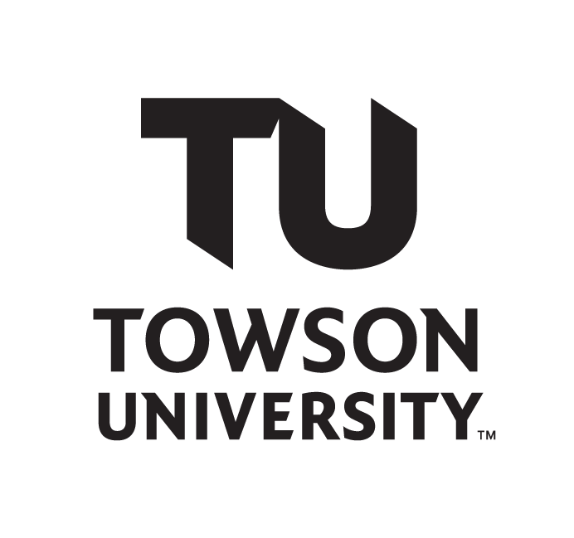
Department of Music
Center for the Arts
Recital Hall

John Doe
Senior Guitar Recital

Sally Sings, voice; Tommy Toots, saxophone;
Willard Walker, bass; Kelly Kicks, drums

Sunday, April 12, 2018 6:00 p.m.

Full House (1962) Wes Montgomery
(1923-1968)

Well, You Needn’t (1944) Thelonius Monk
(1917-1982)

Song for Bilbao (1982) Pat Metheny
(b. 1954)

April in Towson (2018) John Doe
(b. 1999)

This recital is given in partial fulfillment of the requirements for the degree
of Bachelor of Music with a major in jazz commercial guitar performance.
John Doe is a student of Prof. Django Reinhardt.

Please silence all electronic devices.
The use of recording equipment and photography without prior permission of the Department of Music is strictly prohibited.
For your own safety, look for your nearest exit. In case of emergency, walk; do not run to that exit.

