A Self-Paced Tour Through the World of Artificial Intelligence (AI): Applications to Faculty Life

Start here:
- Welcome to this self-guided tour of AI as related to academic life!
- The tasks below (lettered A-J) can be completed in any order. Before starting, go online and load a text-based AI site, such as Microsoft Copilot, ChatGPT, or Google Gemini.
  - You don’t need to complete all tasks. Do whatever seems interesting!
  - Warning: AIs occasionally interpret pasted text passages as images. If this occurs, please type in the prompts manually, try different pasting options, or switch to a different AI.
- In the tasks below, [italicized text] in AI prompts should be replaced with relevant text from your own area(s) of interest or expertise.

Enjoy the tour!

Important Notes:
- AIs train themselves on anything pasted or typed into their interface. Don’t paste an unpublished research article into an AI, for instance, unless you’re ready to share it with the world!

Task A: Survey of Available AIs

Step 1: Copy and paste the following prompt into the AI

What are the five most popular AI sites in use by the general public? List three pros and cons for each.

Step 2: AIs have buttons that allow users to easily copy AI output. As practice, find the copy button associated with the response to the above, copy the AI response, and paste it into a separate document.

Task B: Prompt Engineering

Step 1: Copy and paste the following prompt into the AI

Write a paper on [a topic of your choice].

Step 2: Make the prompt more specific, and reenter the prompt to see how the output changes.

Example:

Write a paper on [a topic of your choice]. The paper should be 750 words, start with a quotation, include pop culture references, and conclude with a 7-line poem in the style of Maya Angelou.

Task C: Lecture Outlines

Step 1: Copy and paste the following prompt into the AI

Generate an outline for a 75-minute, introductory-level university lecture on [a topic of your choosing]. Include (a) five real-life examples of the topics and (b) three common student misunderstandings of the lecture topics.

Step 2: Tell the AI that you’re unhappy with the response, and to try again.

Task D: In-Class Activities to Supplement Lecture

Copy and paste the following prompt into the AI:

Suggest two brief in-class activities that could be used to supplement a university lecture on [a topic of your choosing]. Include three tips for implementing the activities successfully.

Task E: Drafting Letters of Recommendation

Step 1: Copy and paste the following prompt into the AI

Draft a 200-word recommendation letter for an [enter major] undergraduate student applying to graduate school. In the letter, emphasize their passion for the subject, attention to detail, frequent communication, and love of fruits and vegetables.

Step 2: Ask the AI to rewrite the letter using old-time Western slang.

Task F: Drafting Grant Proposal Outlines

Step 1: Copy and paste the following prompt into the AI

Generate 500-word outline for a grant proposal on the topic of [insert topic]. The proposal should include a project summary, project description, required facilities and resources, and a [insert dollar amount] budget with appropriate justifications.

Task G: Guided Student Usage of AI

MagicSchool is a website that allows instructors to set up an AI interface for their students. When students interact with the interface, a transcript is generated that the instructor can access later.

To explore this website from the student perspective, click on the link below:

https://student.magicschool.ai/s/join?joinCode=eFJZzA

Task H: Exams and Other Assessments

Step 1: Copy and paste the following prompt into the AI

Create a multiple-choice exam for a general education university physics course on the topic of force and motion. The 20-question exam should contain 25% mathematical questions and 75% conceptual questions.

Step 2: Copy and paste the following prompt into the AI

Create a short-answer exam for a general education university physics course on the topic of force and motion. The 10-question exam should contain 20% mathematical questions and 80% conceptual questions.

Step 3: Copy and paste the following prompt into the AI

Give five examples of non-traditional assessments for a general education university physics course on the topic of force and motion. Provide a grading rubric for each.

Task I: Limitations of AI

Step 1: Copy and paste the following prompts into the AI

What prompts are the most difficult for AIs to answer? Why?

What prompts are most likely to result in incorrect AI output? Why?

Step 2: Try to find additional tasks the AI can’t help you with!

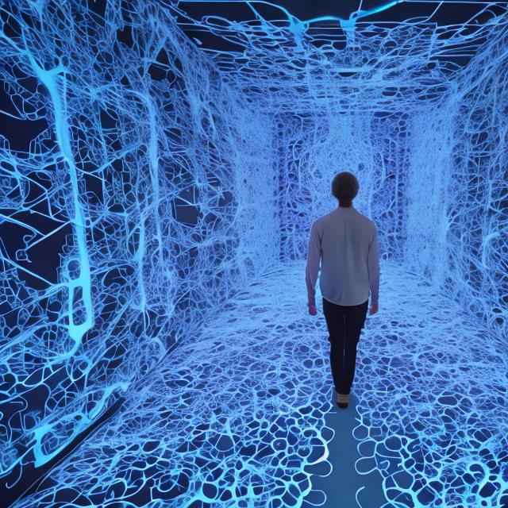

Image generated by OpenArt AI

Task J: Novel Use of AI in Course Assignments and Activities

Below are five examples of innovative uses of AI in course activities and assignments. Paste each prompt into an AI and explore the results. Feel free to modify the language to fit your own courses and areas of expertise.

Prompt 1:

I want you (the AI) to act as a sarcastic tutor for an anthropological theory class for college seniors. The class presents contemporary issues in anthropological theory, including culture, power, and identity. I don’t know much historical background and would benefit from historical context. Your tone should be critical and funny, and your responses should be clear and brief. Answer my questions with other questions to check my understanding. Are you ready? If so, please suggest a starting topic.

Prompt 2:

Write a projectile motion problem, with a hint (no more than 20 words) for getting started. The hint should be general advice, not specific steps or formulas for solving the problem. If I type the word “stuck,” that means I am trying to solve the problem and need help. If I type the word “answer,” that means I am ready for a solution with detailed commentary.

Prompt 3:

Generate 10 interview questions to guide a teacher’s reflection on a 2nd grade lesson on the topic of creative writing.

Prompt 4:

You (the AI) will play the gamemaster for simulated biological fieldwork set in the Galapagos Islands in the early 1800s. Using a 'choose your own adventure' framework, present me with five encounters (one at a time) with flora and fauna on the island. The final encounter should include rainbows and a friendly interaction with aliens from outer space. Give me between 3-5 choices for my response to each encounter. Choices should include actions and interpretations I might make as a biologist.

Prompt 5:

You (the AI) will create an “escape room” experience for high school students with four separate rooms. Room 1 should focus on social studies, room 2 should focus on poetry, room 3 should focus on mathematics, and room 4 should focus on music. Provide each room with a fun title and an entertaining description, but only provide information for one room at a time. Each room should have two puzzles, and participants can’t move to the next room until both puzzles are solved. If I type “hint 1” or “hint 2” into the text box, I want brief hints for puzzle 1 or puzzle 2, respectively. If I type “solution 1” or “solution 2” into the text box, I want the solution to puzzle 1 or puzzle 2, respectively. If I type “new puzzles” into the text box, I want new puzzles for the current room.

Take-Aways from the AI Tour
- There are numerous AIs available, each with its own focus: text output and problem solving, image modification, generating images from text descriptions, generating music compositions, video generation, or other foci. Some AI can be used freely, and others require accounts.
- The user must decide to what extent a specific usage of AI is ethical and appropriate in academic life. Please keep this is mind when applying AI-generated content to the areas of teaching, service, and scholarship, including the appropriate citation of AI sources.
- Prompt engineering is key to generating useful AI output. Multi-sentence prompts with detailed guidelines tend to provide the most useful output.
- AI might be used by faculty in many ways: grant, article, and lecture outlines; letter drafts; classroom activities and assignments (including assignments that integrate AI); course assessments; and many other applications.
- Websites exist that allow students to interact with AIs under the guidance of the course instructor.
- AIs have limitations on the information they can generate in terms of accuracy, bias, ethical considerations, and completeness.

Thanks for taking the tour!

